Notes on “Condition Report on Northampton Country-Owned Bridges”

1. Two largest groups of bridges in Northampton Co., age-wise, are in the 25-50 and 75-100 year old categories. Targeting the 25-50% category may yield the best results as these will be modern construction. These bridges will likely have been designed with ASD and HS-20-44.
2. Comparison was made between the average state of North Co. bridges and PA municipalities, as well as PennDOT-owned bridges and Nationwide, for the following categories: % Structurally Deficient (SD), % Functionally Obsolete (FO), % Load Posted (LP), Ave. Sufficiency Rating (ASR), and Ave. Age (AA). North Co. has worse statistics in all categories when compared to PennDOT-owned and Nationwide averages, with one exception: the AA of North Co. bridges is less than that of PennDOT. North Co. performs worse than average PA municipalities in FO, LP, ASR, and AA. It performs better than the average PA municipality in SD. Load posting would be a great target, so we can return to North Co. and help them perform better than the average county.
   1. Several bridges that are not SD are load posted due to insufficient documentation. Borton-Lawson, North Co., and PennDOT have “initiated an investigation” to reassess if these postings are necessary.
3. 19 County-owned bridges are listed as Priority 1 maintenance. This designation requires a plan of action within 6 days and repair work within 6 months. 3 of these have already been repaired. The other 16 have “outstanding critical deficiencies” that require “rehabilitation, replacement, or removal.” The cost for this work exceeds North Co. budget. PennDOT has allowed North Co. to extend deadline.
   1. Intermediate step of load posting, traffic diversion, etc. has been enacted for these 16.
   2. Temporary structural measures have been installed.
   3. These bridges should be our target, if possible. Saving the county from the expense of rehab/replace would be a big win.
   4. List of bridges and applicability of RAMPS:
      1. **Bridge 31 –** Small through-truss
         1. Heavy section loss in floor stringers at abutments. Temp support placed under deck slab. Truss itself looks fine. Recommended for removal due to redundancy. Not a good candidate due to truss.
      2. **Bridge 72 –** Medium through-truss
         1. Heavy section loss in floor stringers at abutments. Temp support placed under deck slab. Truss itself looks fine. Recommended for removal due to redundancy. Not a good candidate, due to truss.
      3. **Bridge 90 –** Steel stringer/concrete deck
         1. Sheared bolts on bearings. Elastomeric bearings were scheduled to be installed 2013. Check current status. Not really a candidate due to it being a bearing bolt issue.
      4. **Bridge 94 –** Steel stringer/floor-beams and steel grate deck
         1. Section loss in floor beams. Intend to replace with concrete deck, however now current plans. Check current status. This could be a candidate, but check to see status of deck replacement. Main girders are likely fine.
      5. **Bridge 95 –** Masonry arch steel floor beam and grate deck
         1. Section loss in floor beams. Again, not a candidate because it’s a local issue with floor beams. Also, masonry arch.
      6. **Bridge 99 –** Small truss
         1. Section loss in stringers. Currently posted. Recommended for replace or rehab. Not a good candidate due to truss.
      7. **Bridge 213 –** steel stringer with concrete deck
         1. Section loss in beams at ends. Posted for 25 tons, so not a drastic posting. This could be a lay-up. This should be a candidate.
      8. **Bridge 75, 107, 127, 133, 135, 144, 166, 218, 220 –** non-composite pre-stressed adjacent box beam bridges with bituminous overlay.
         1. Due to nature of non-composite adj. box beams, PennDOT has revised safety standards. If cracks form on fascia beam under parapet joints, bridge is automatically scheduled for priority 1 maintenance. 9 out of North Co.’s 18 pre-stressed adj. box bridges exhibit fascia cracking.
         2. Plan of action for all bridges is removal of bituminous deck, inspection/regrout of shear keys, replacement of cracked fascia beams (?!), replacement of parapets, resurface of deck.
         3. These may not be a candidate while cracked fascia beams are in place, as the priority 1 maintenance will still stand.
4. 50% of bridges are not eligible for federal funds. Engineer of record recommends preventative maintenance for these bridges. The other 50% are eligible for federal funds for either replacement (22%) or rehabilitation (28%).
5. County council voted on bond issue in May 2013. Bond was issued for $11+ million, which covers the $7+ needed for minimum level remediation. Remediation efforts were funded for the following bridges: **31, 99, 75, 107, 127, 133, 135, 144, 166, 218, 220, 94, 95, 72, 213, 103, 187. Bridge 90** bearing replacement was funded through other measures. **Bridge 213** could be a good candidate for testing ($148,300 allocated).

Recommended Bridges for THMPR

|  |  |  |  |  |  |  |  |  |  |
| --- | --- | --- | --- | --- | --- | --- | --- | --- | --- |
| Bridge No. | Type | ADT | Length | Spans | Age | Posted Tons | Deck/SUP  /SUB | SD/FO? | Suff. Rat. |
| 41 | Conc. Enc. I-Beam | 200 | 88 | 2 | 67 | 20 | 6/5/5 | n/n | 45.7 |
| 63 | Conc. Enc. I-Beam | 150 | 100 | 3 | 90 | 16 | 6/5/5 | n/y | 34.8 |
| 66 | Steel I-Beam | 250 | 53 | 2 | 99 | 15 | 5/6/6 | n/y | 77.8 |
| 102 | Conc. Enc. I-Beam | 200 | 45 | 1 | 89 | 20 | 6/5/3 | y/y | 21.5 |
| 105 | P/S Adj. Box Beam | 60 | 33 | 1 | 29 | 34 | 7/6/7 | n/n | 90.1 |
| 117 | Conc. Enc. I-Beam | 700 | 32 | 1 | 79 | 16 | 6/5/5 | n/n | 85.9 |
| 124 | Steel I-Beam | 200 | 42 | 1 | 55 | 20 | 4/6/6 | y/n | 84.4 |
| 138 | Conc. Enc. I-Beam | 150 | 51 | 1 | 67 | 10 | 6/5/5 | n/y | 36.4 |
| 146 | Steel I-Beam | 90 | 29 | 1 | 93 | 9 | 5/6/4 | y/n | 38.2 |
| 191 | Conc. Enc. I-Beam | 400 | 47 | 2 | 91 | 13 | 4/4/2 | y/y | 17.1 |
| 200 | Conc. Enc. I-Beam | 400 | 44 | 1 | 89 | 30 | 5/6/5 | n/n | 81.1 |
| 205 | Conc. Enc. I-Beam | 100 | 28 | 1 | 86 | 20 | 6/6/6 | n/n | 60.5 |
| 207 | Steel I-Beam | 100 | 25 | 1 | 62 | 8 | 6/6/6 | n/y | 64.6 |
| 210 | Conc. Enc. I-Beam | 100 | 45 | 1 | 83 | 13 | 5/4/4 | y/n | 40.9 |
| 213 | Conc. Enc. I-Beam | 300 | 25 | 1 | 103 | 25 | 6/4/5 | y/n | 51.0 |
| 215 | Conc. Enc. I-Beam | 150 | 29 | 1 | 84 | 20 | 6/6/4 | y/y | 23.7 |
| 224 | Steel I-Beam | 100 | 25 | 1 | 68 | 7 | 6/5/5 | n/y | 73.6 |

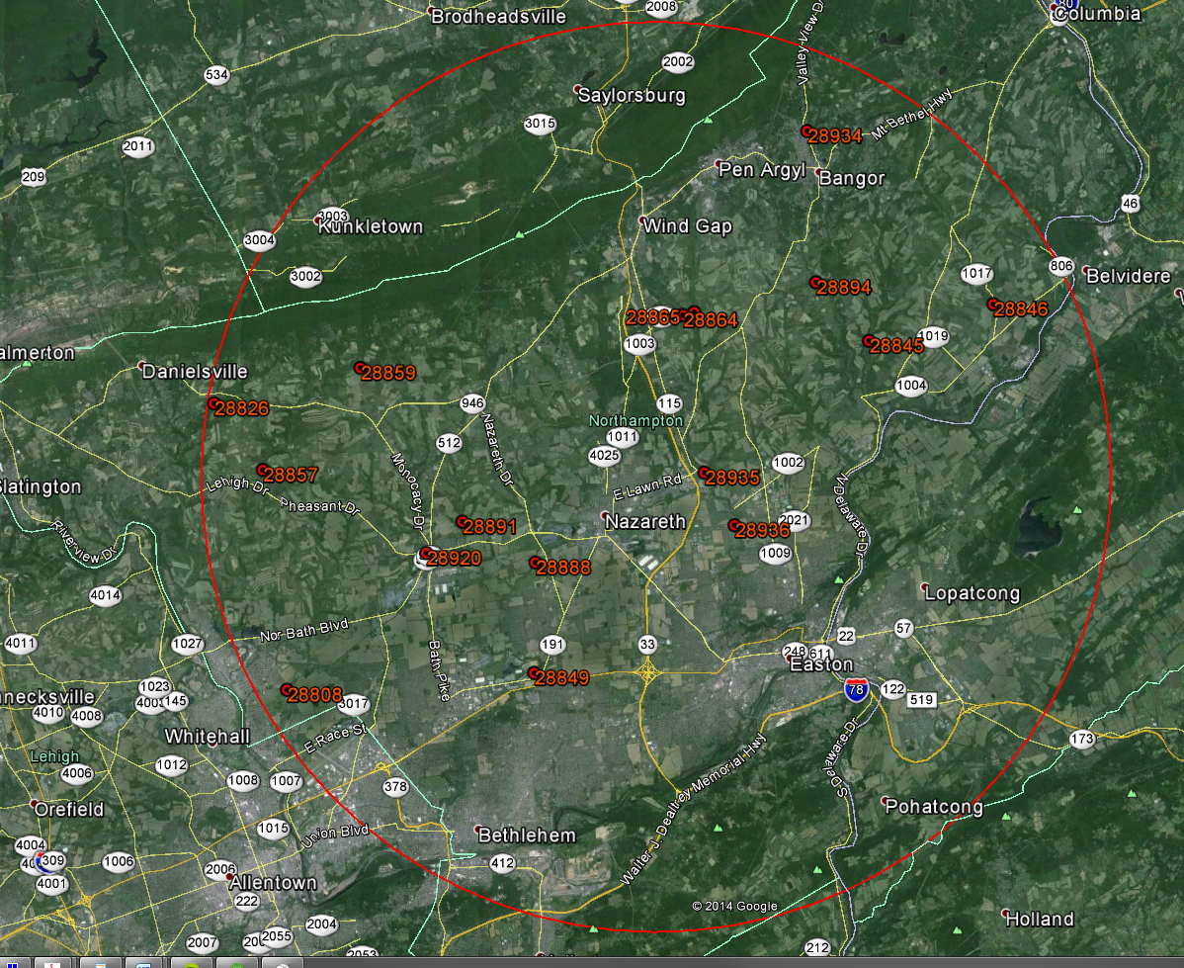

Radius approximately 11.5 miles

**Co#: BMS#: NBI#**

**41: 48-7208-0684-9041: 28839**: 2 span continuous. Low clearance over semi-dry stream bed. Decent access. Design load unknown. Concrete deck.

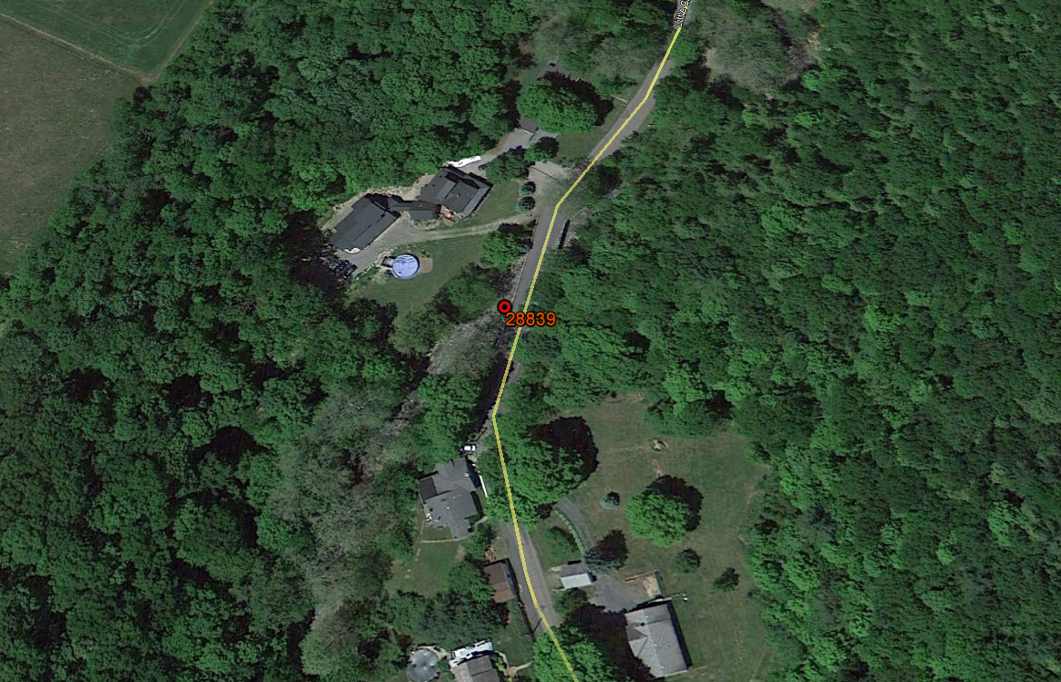

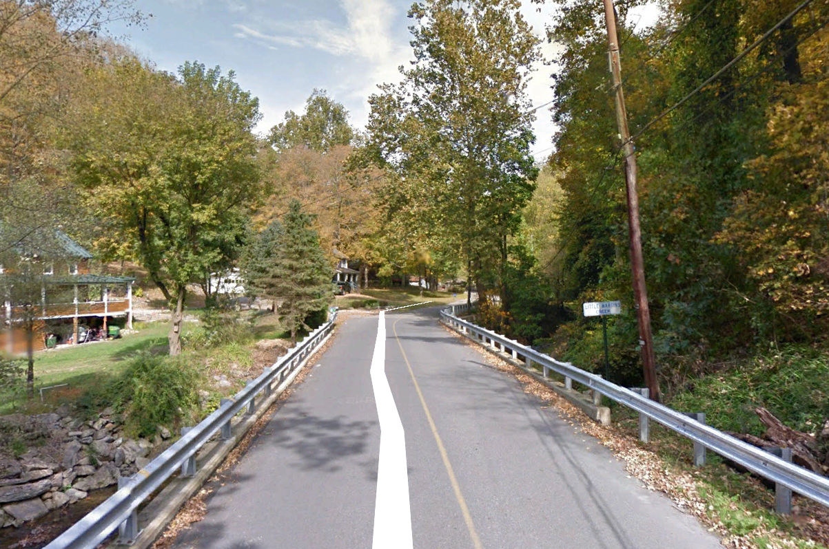

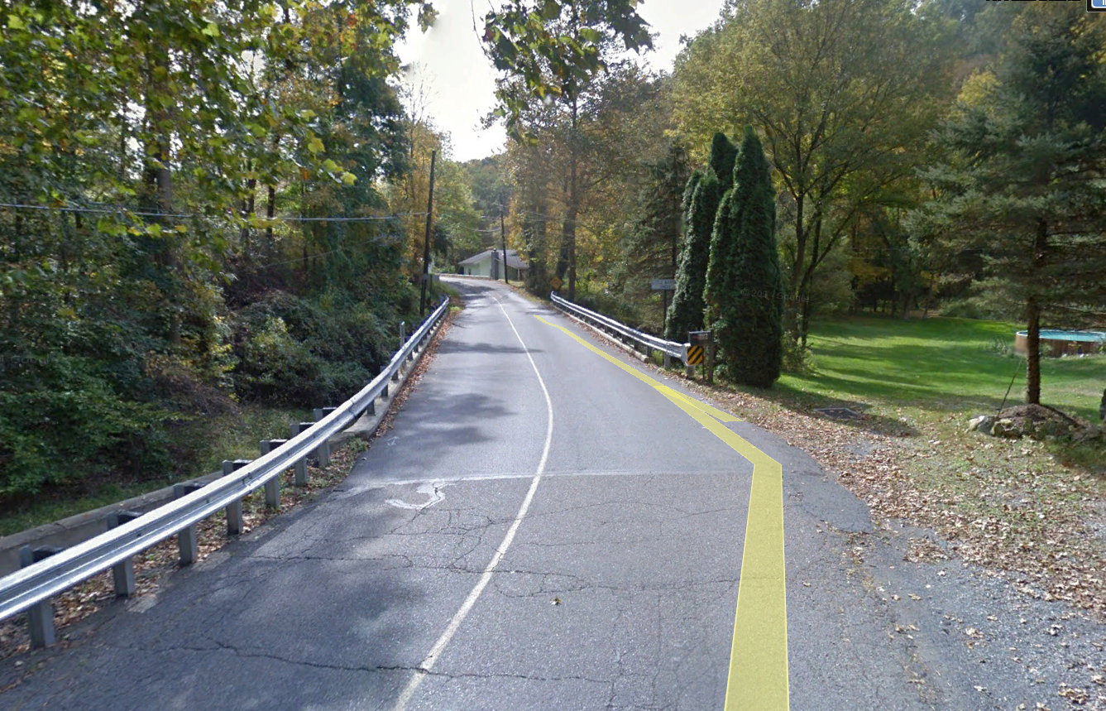

**63: 48-7415-0000-9063: 28936**: 3-span continuous. Higher structure over medium creek. Good topside access. Design load unknown. Concrete deck.

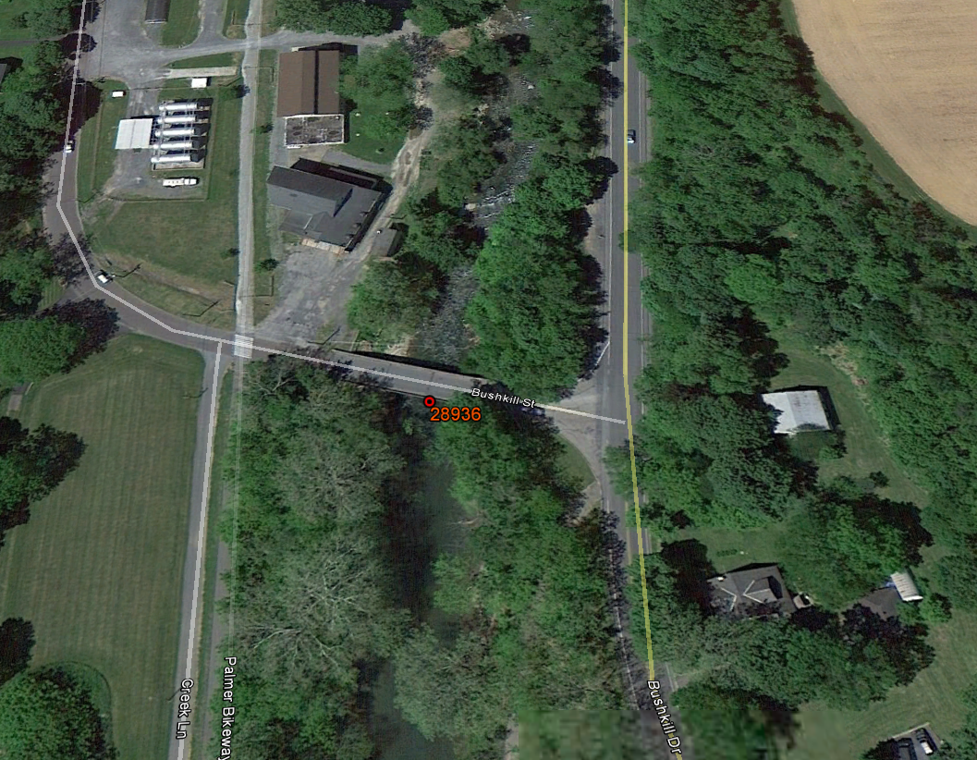

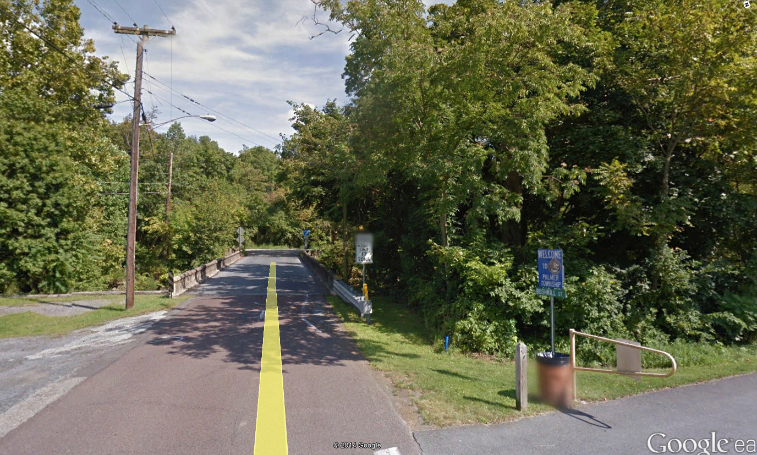

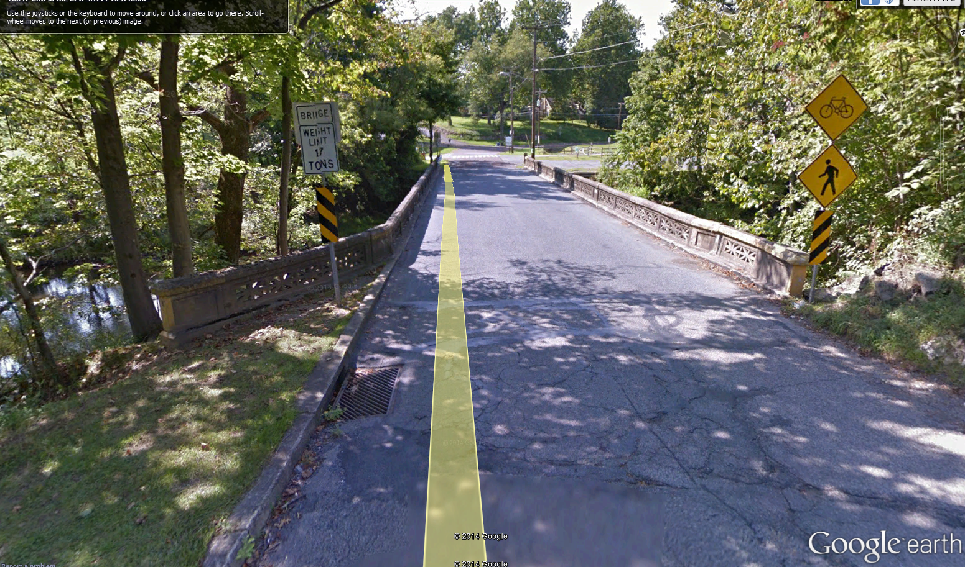

**66: 48-7414-0627-9066: 28935**: Single span. Open grate steel deck. One lane. Stone abutments. Medium height over low creek. H-15 design load.

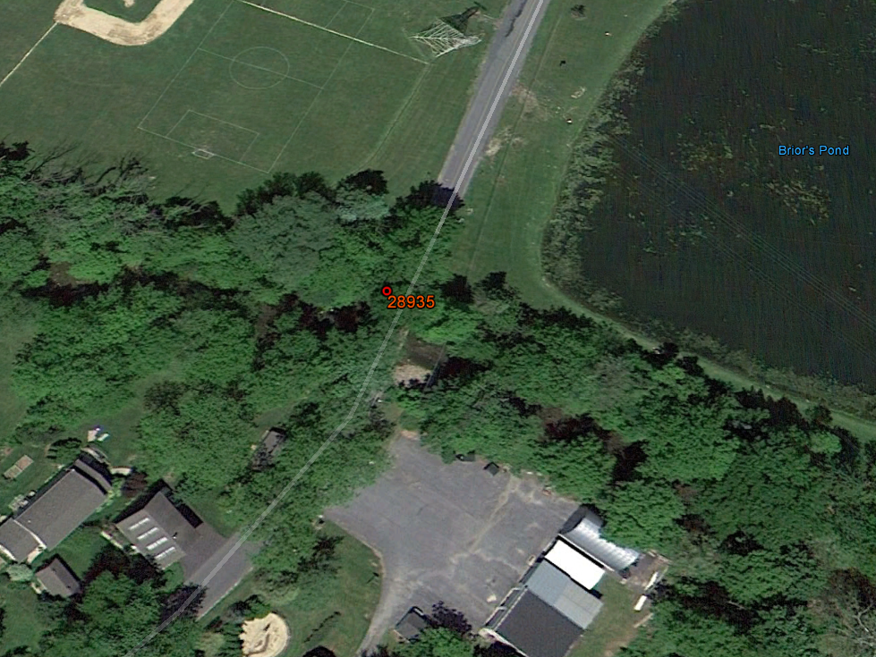

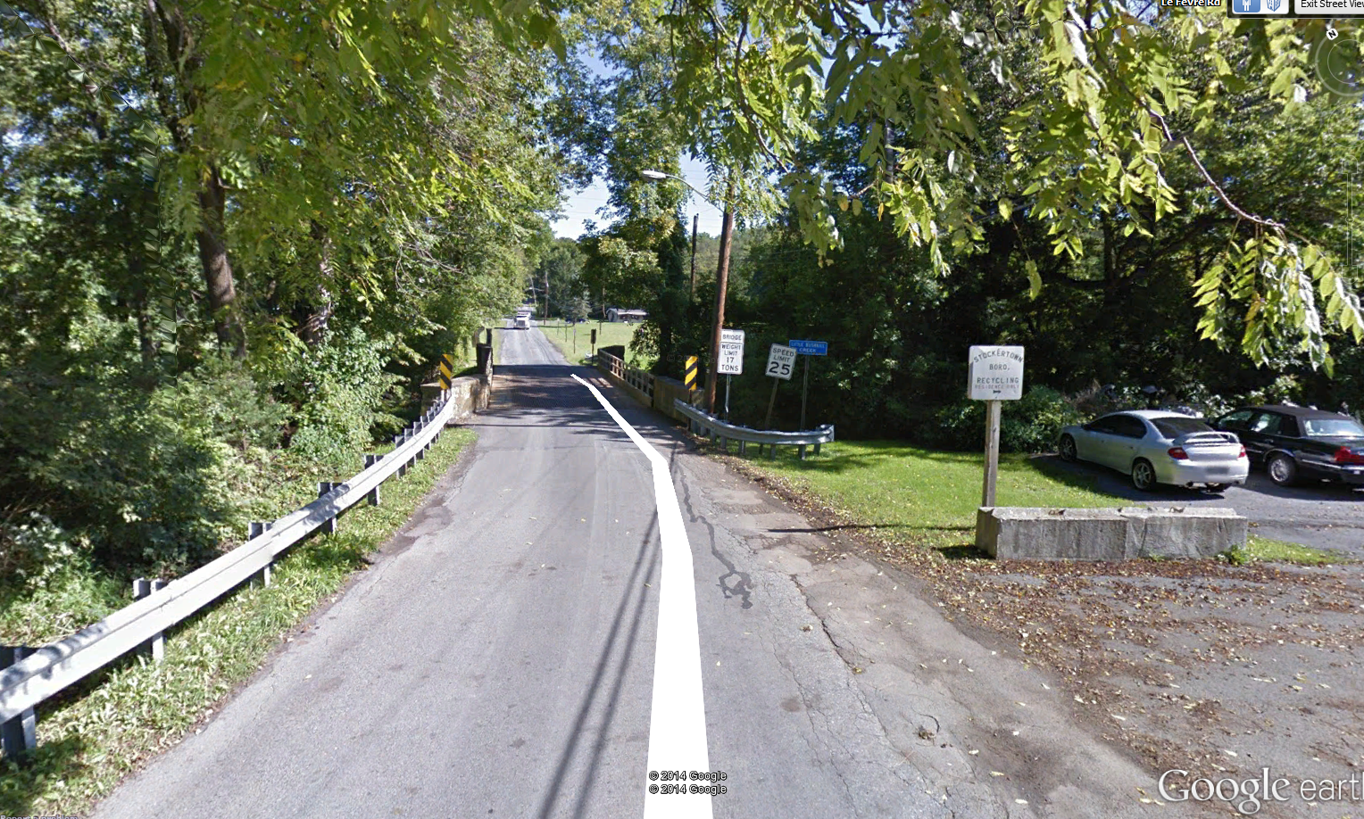

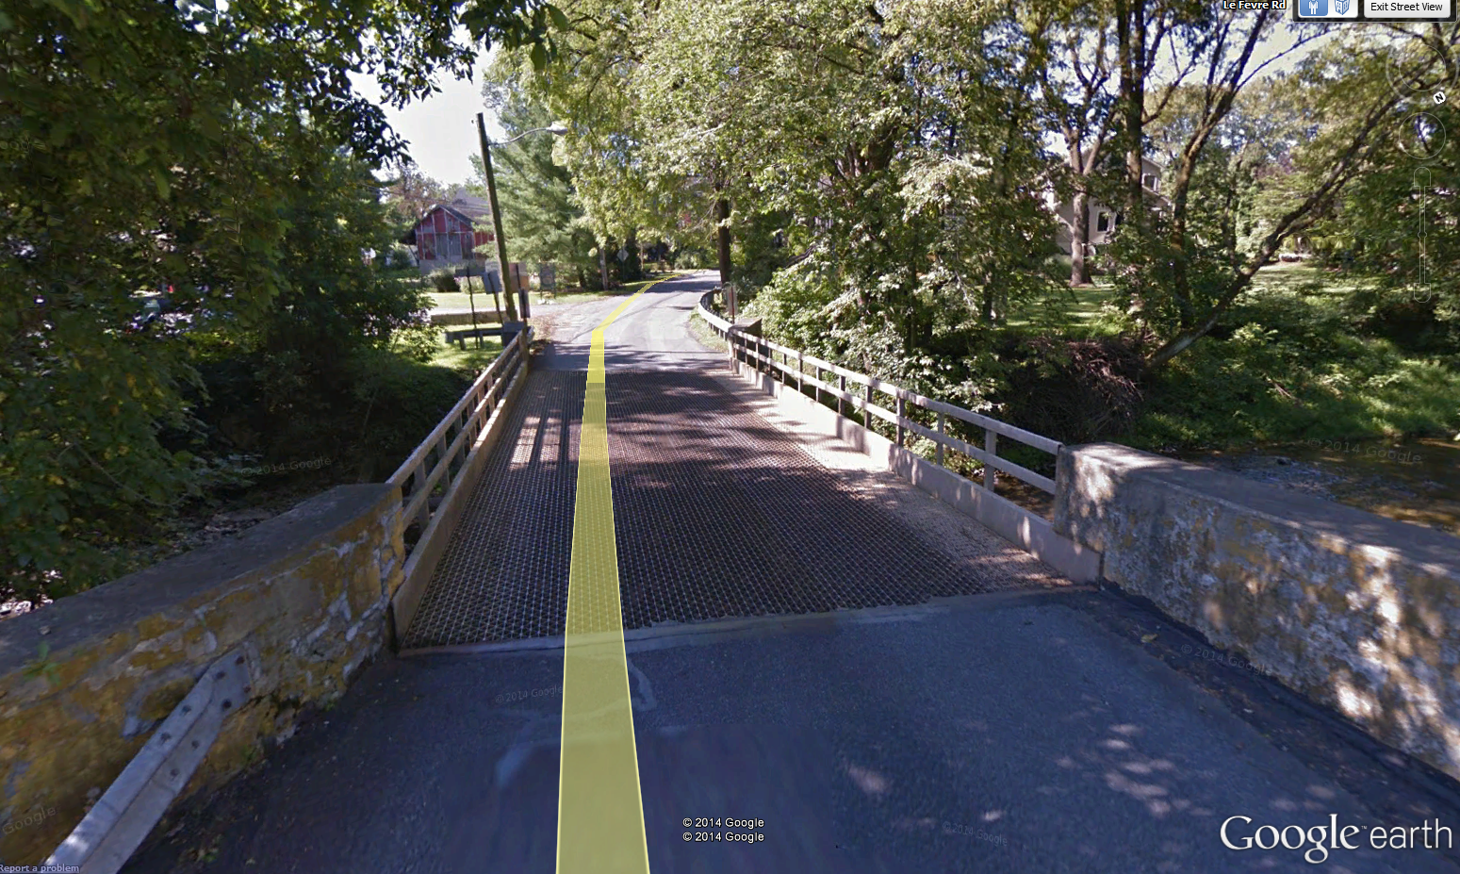

**102: 45-7209-0436-9102: 28849**: Single span. Bituminous paving. One lane. High over medium creek. Abuts railway crossing. Unknown design load.

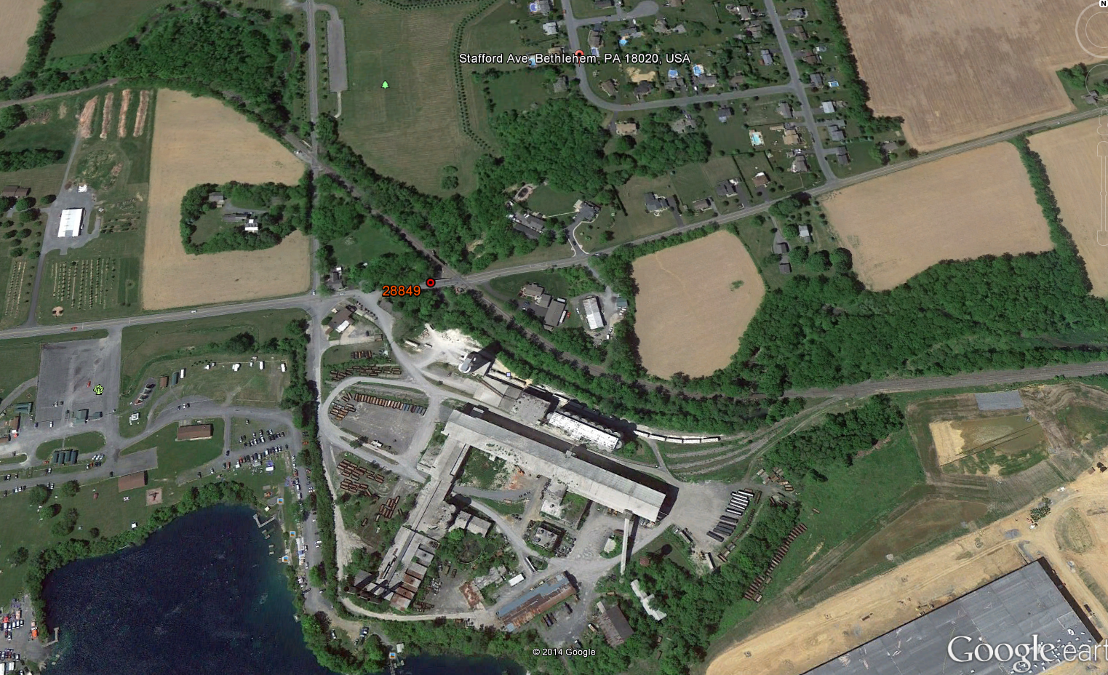

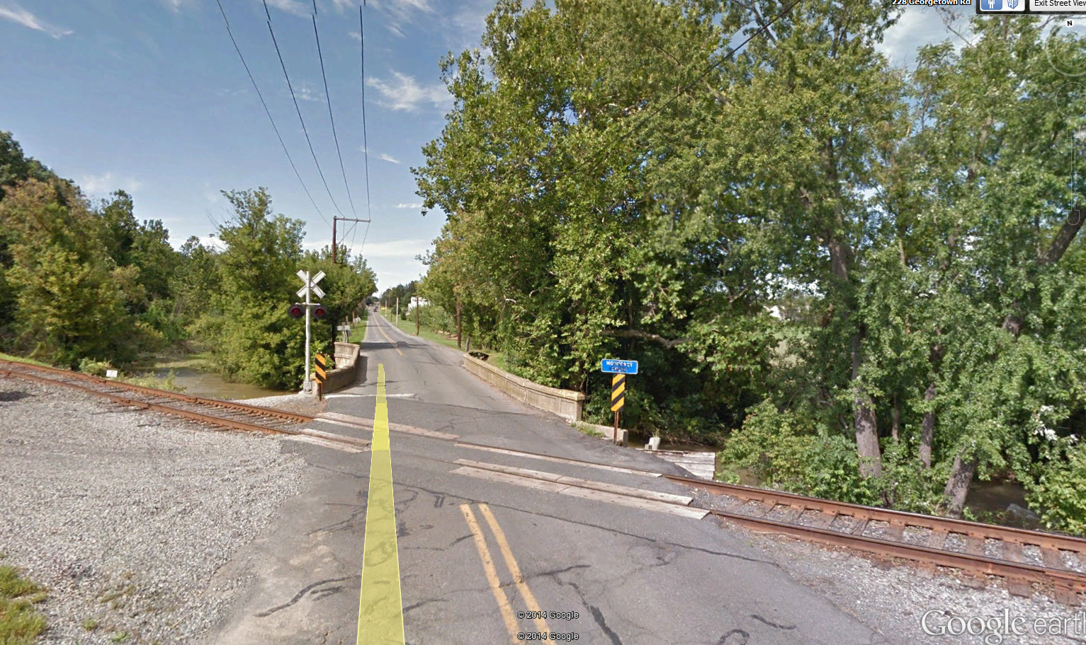

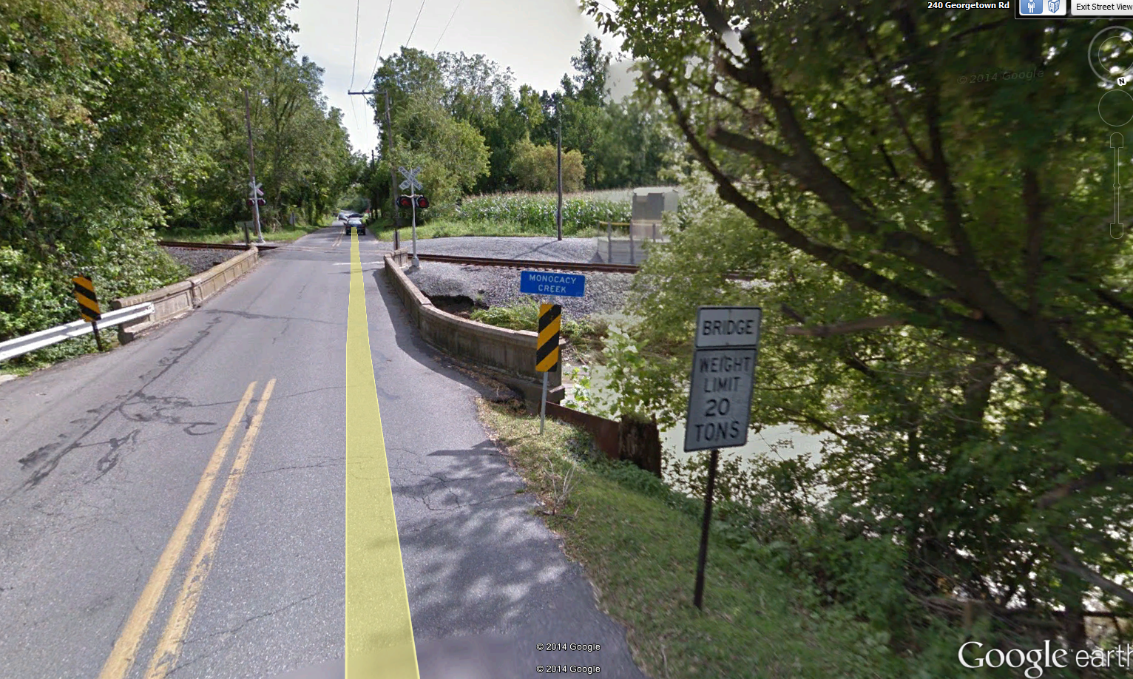

**105: 48-7215-0483-9105: 28888**: Singe span. Low over medium creek. Good access topside. Bituminous paving. Design load HS-20.

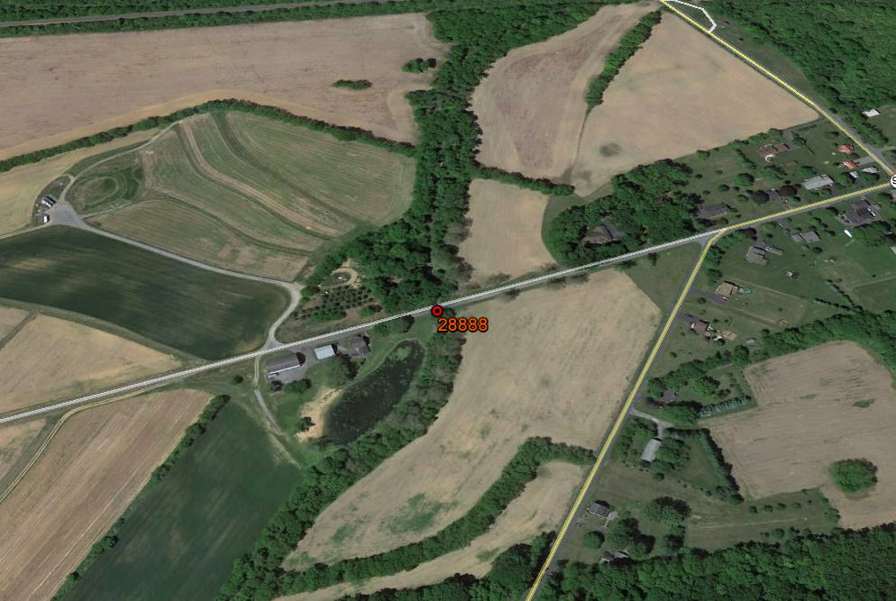

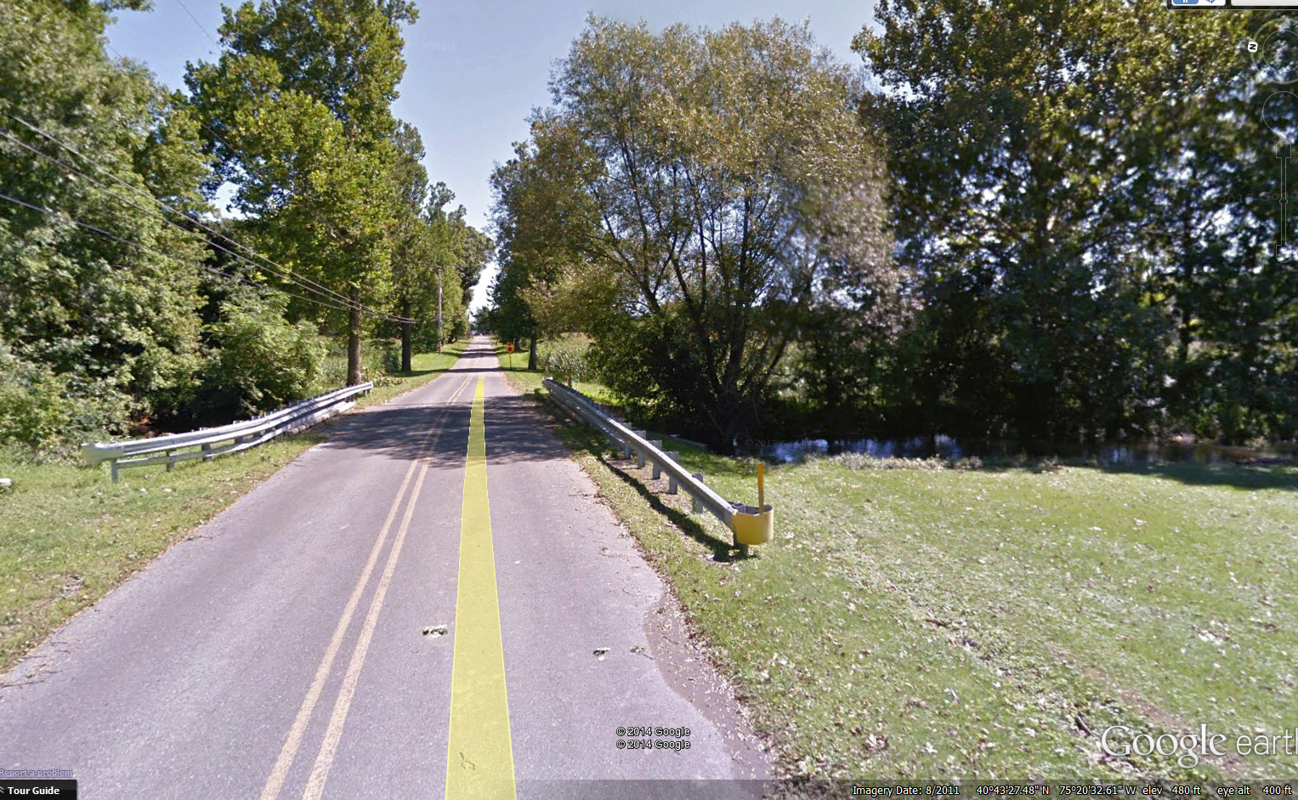

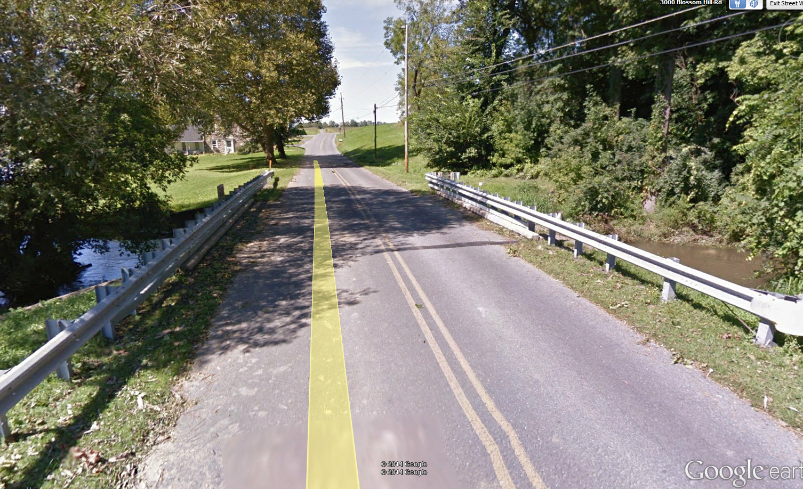

**117: 48-7402-0000-9117: 28920**: Single span. Bituminous pavement. Low over shallow wide stream. Abuts intersection in town. Wide road and sidewalks. Design load unknown.

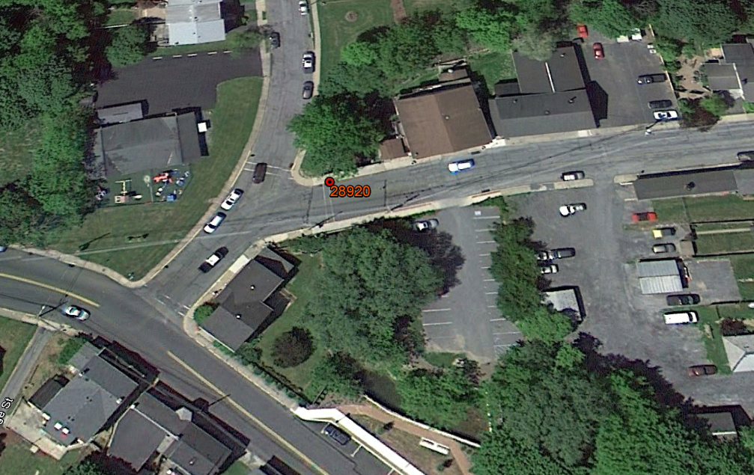

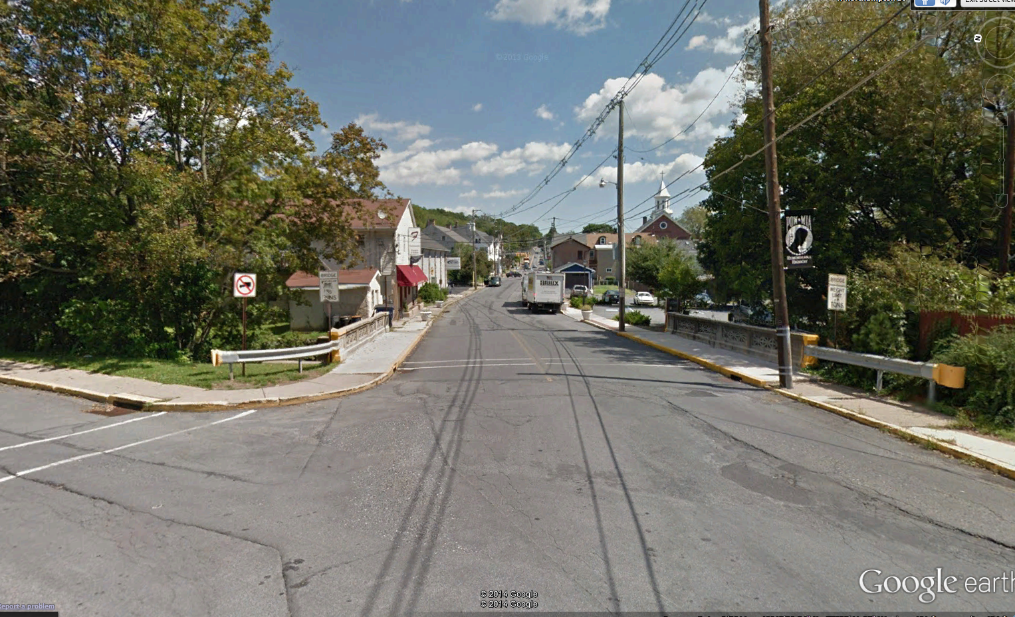

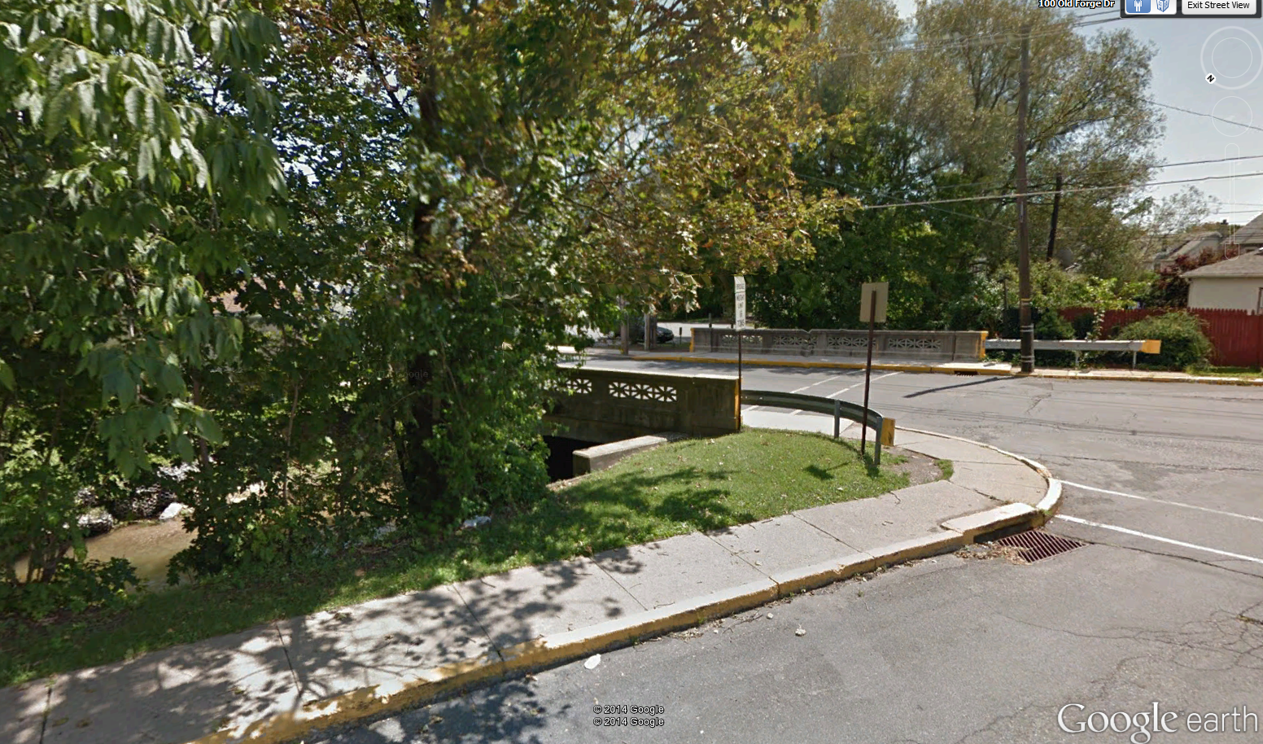

**124: 48-7201-0478-9124: 28808**: Single span. Open grate steel deck. Low over wide shallow stream. Decent underside and top access. HS-20.

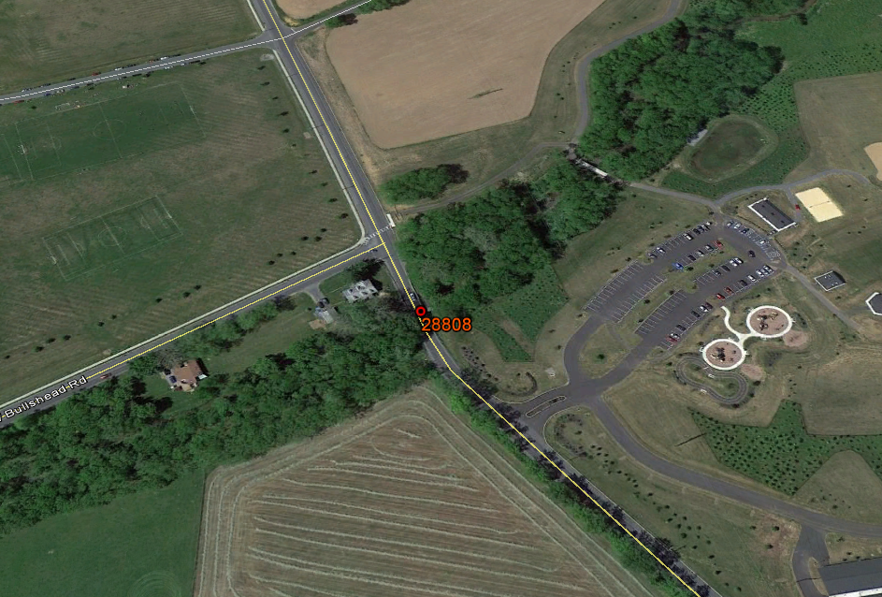

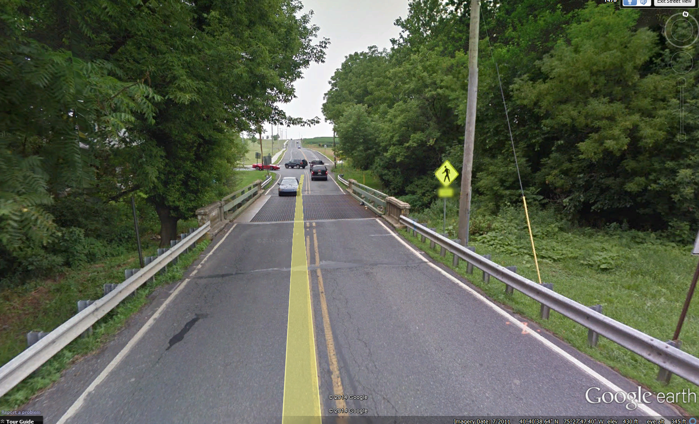

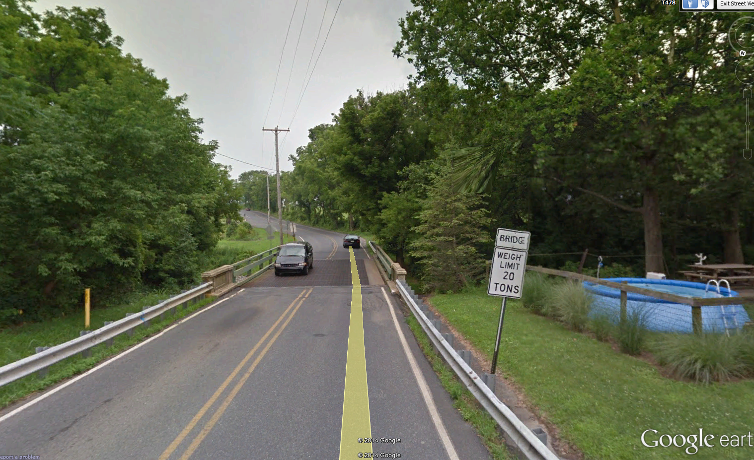

**138: 48-7211-0564-9138: 28857**: Single span. Bituminous pavement. Medium height over wide medium creek. Abuts intersection. Unknown design load.

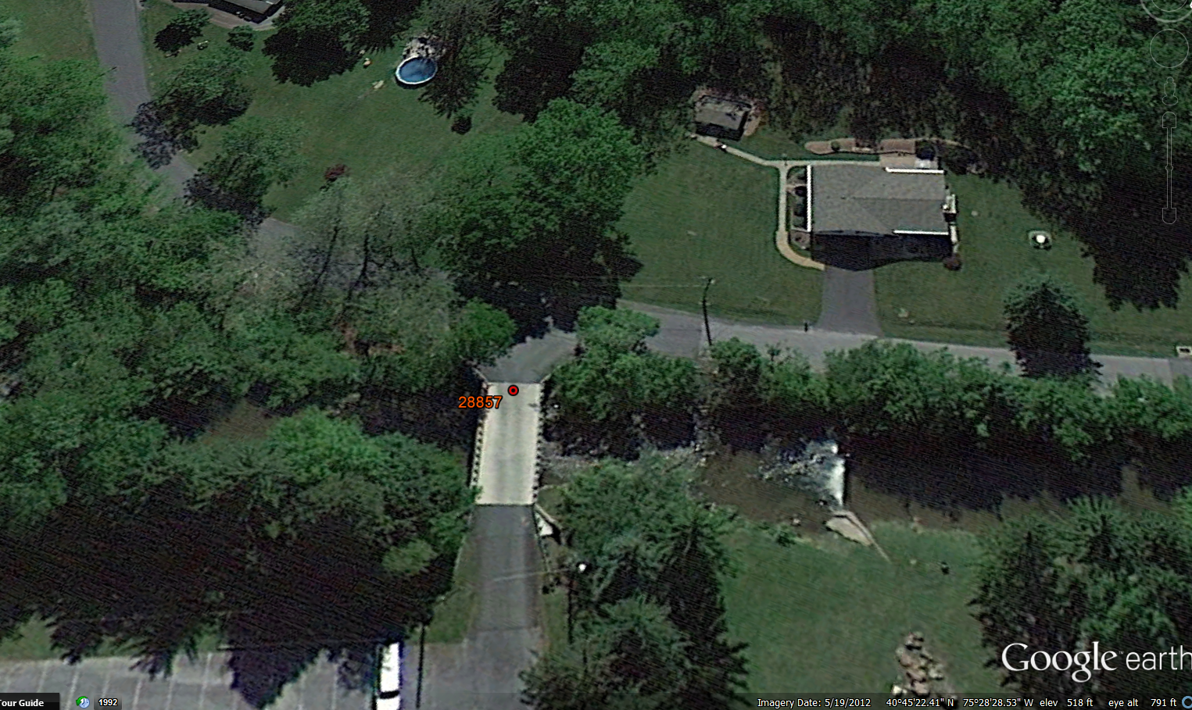

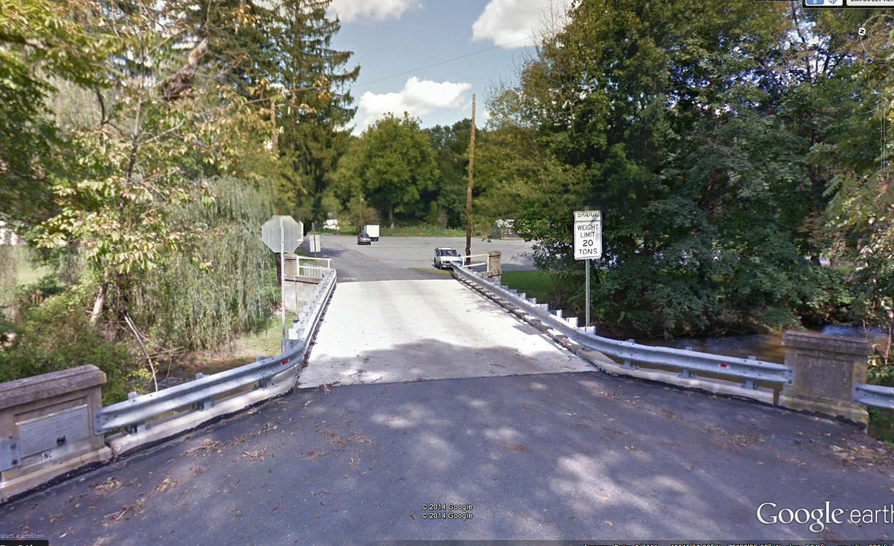

**146: 48-7211-0588-9146: 28859**: Single span. Bituminous pavement. One lane. Low height over small stream. Stone abutments. Very narrow (14’) roadway. Easy access.

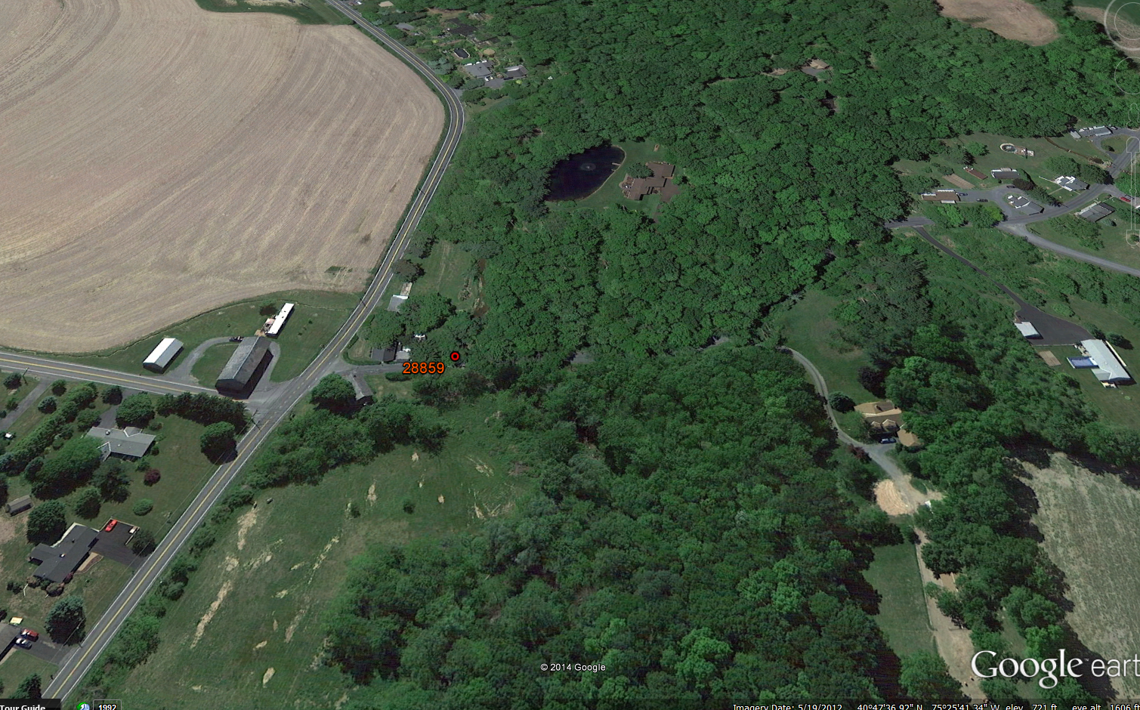

**191: 48-7216-0667-9191: 28894**: 2-span continuous. Bituminous pavement. One lane. One span is very low over grass. Other span over large stream. Design load unknown.

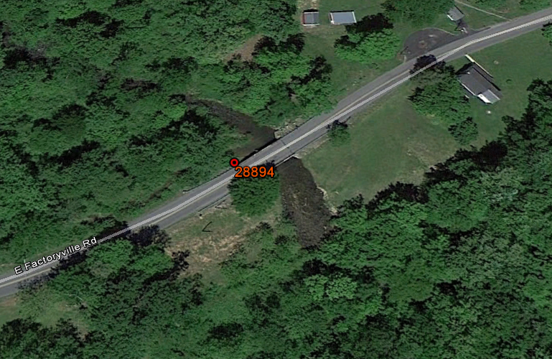

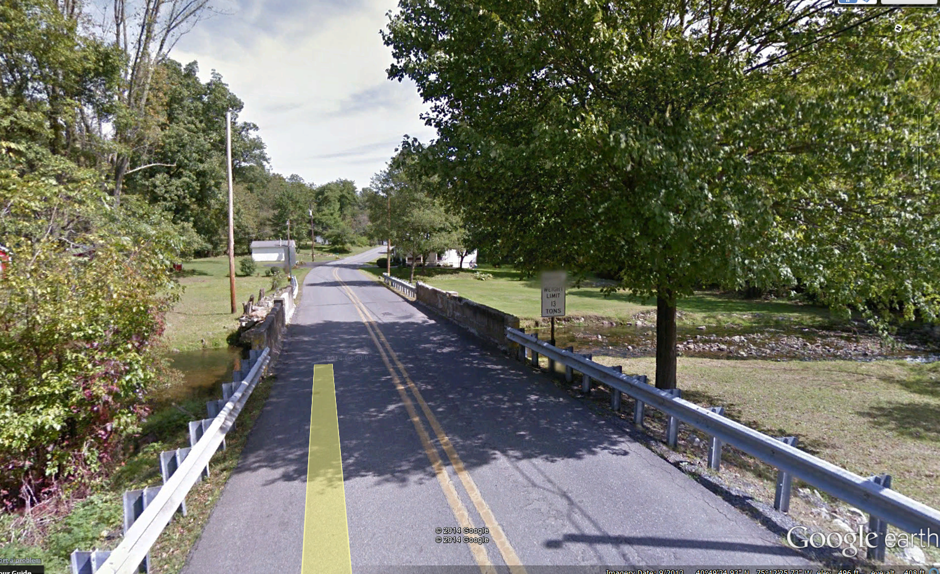

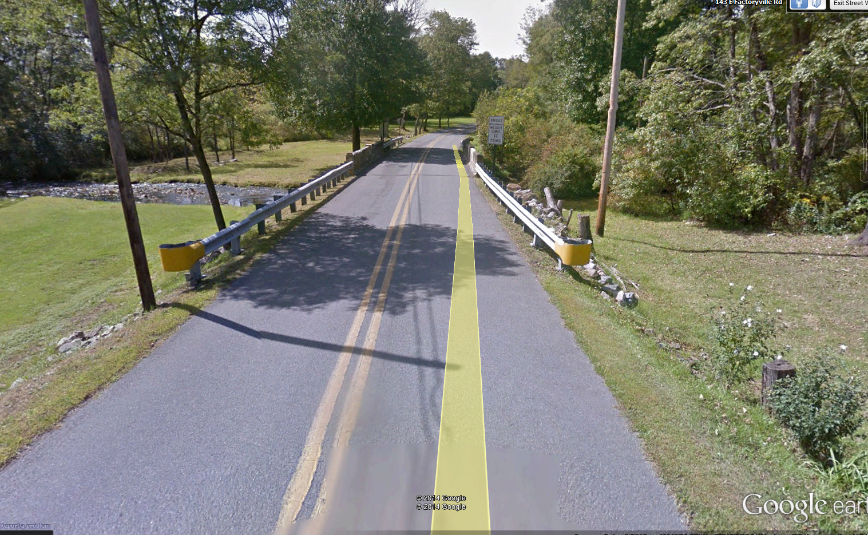

**200: 48-7413-0000-9200: 28934**: Single span. High over dry creek bed. Bituminous pavement. Wide street and sidewalks. Near town. Design load unknown.

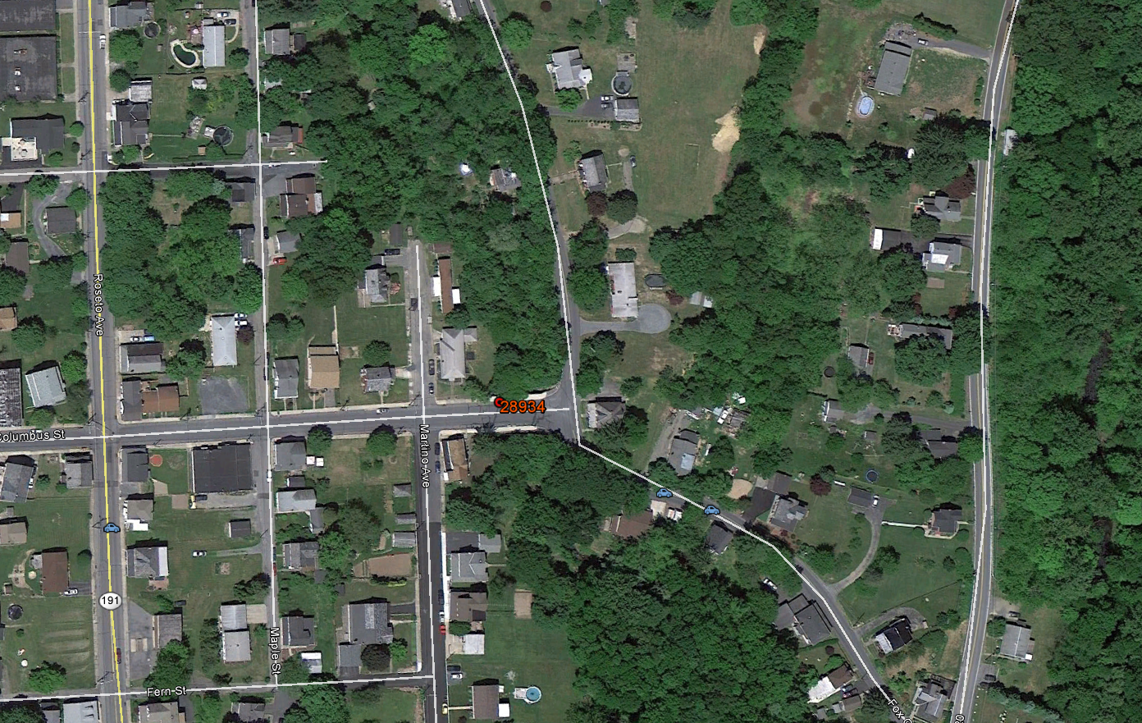

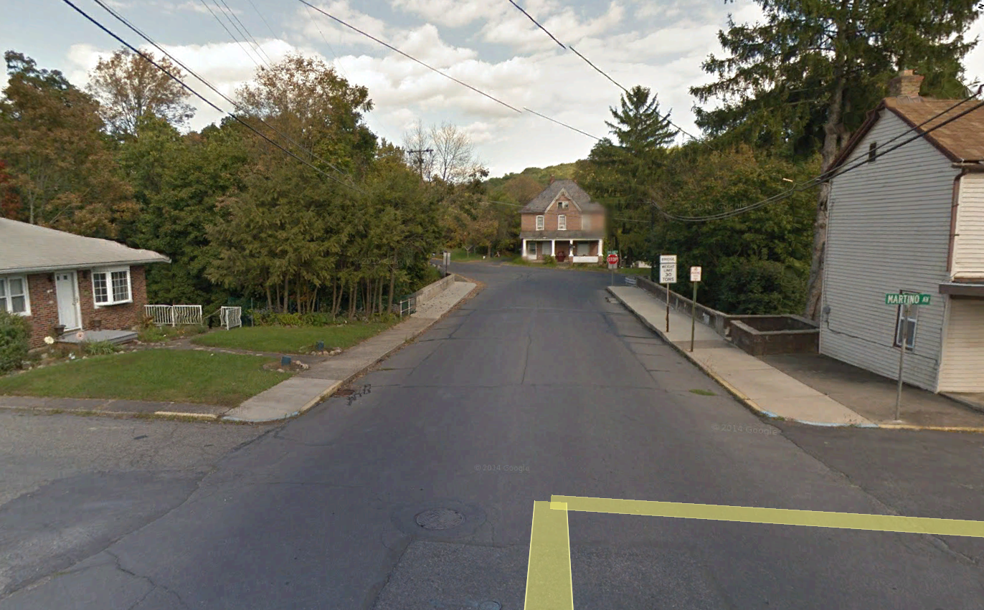

**205: 48-7207-0474-9205: 28826**: Single span. Bituminous pavement. One lane. Medium height over medium creek. Design load unknown.

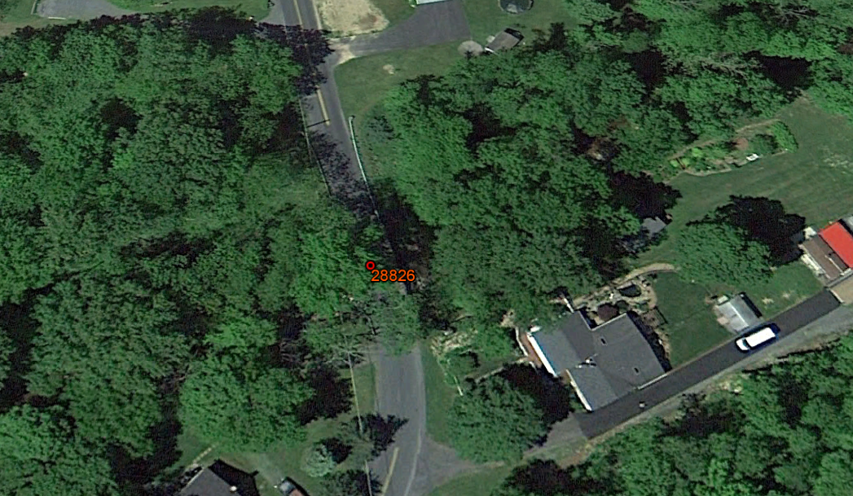

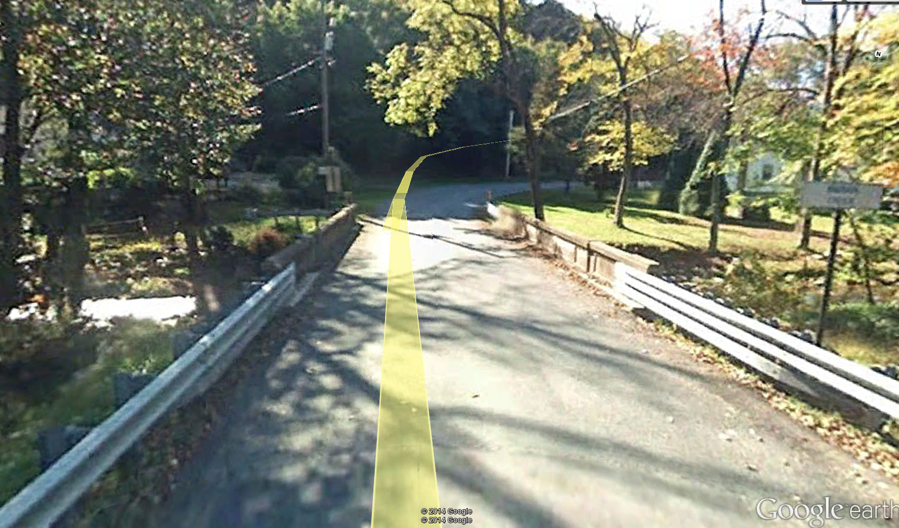

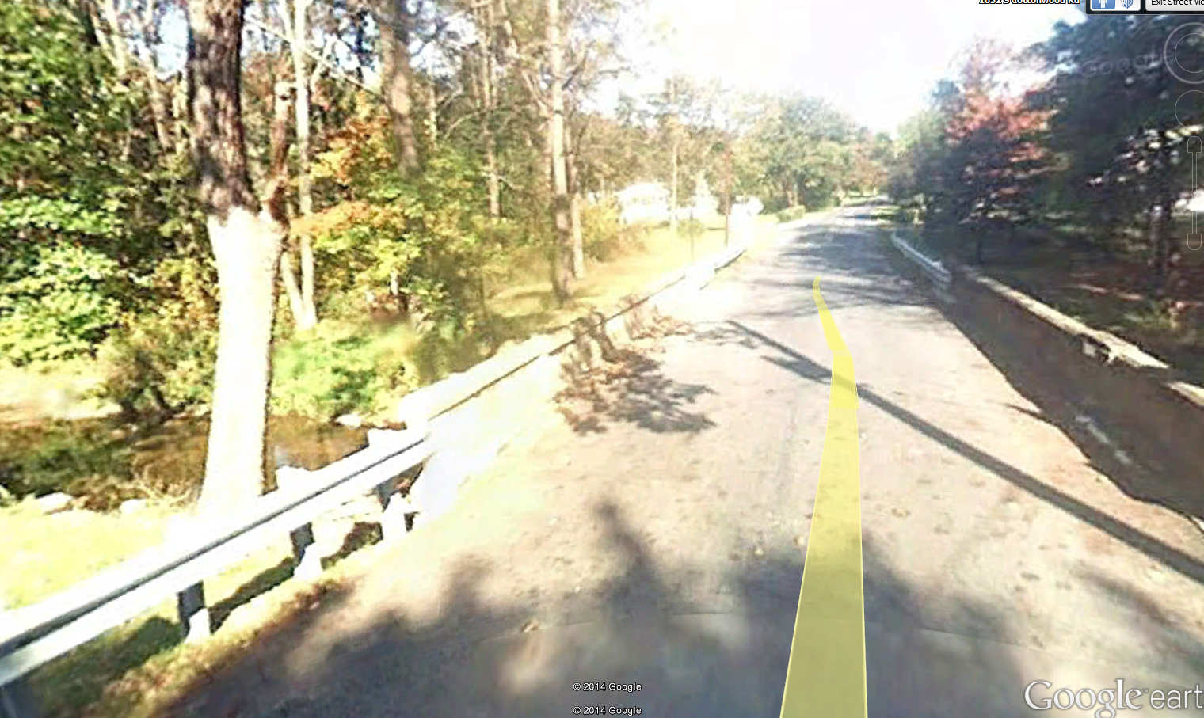

**207: 48-7213-0629-9207: 28864**: Single span. Open grate steel deck. One lane. Low over wide shallow creek. Design load H-15. Narrow (17’) with winding approaches.

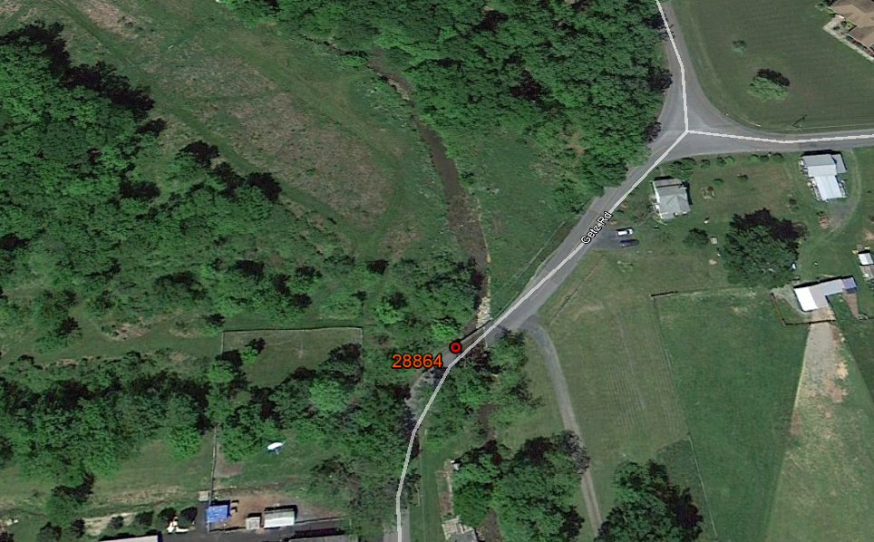

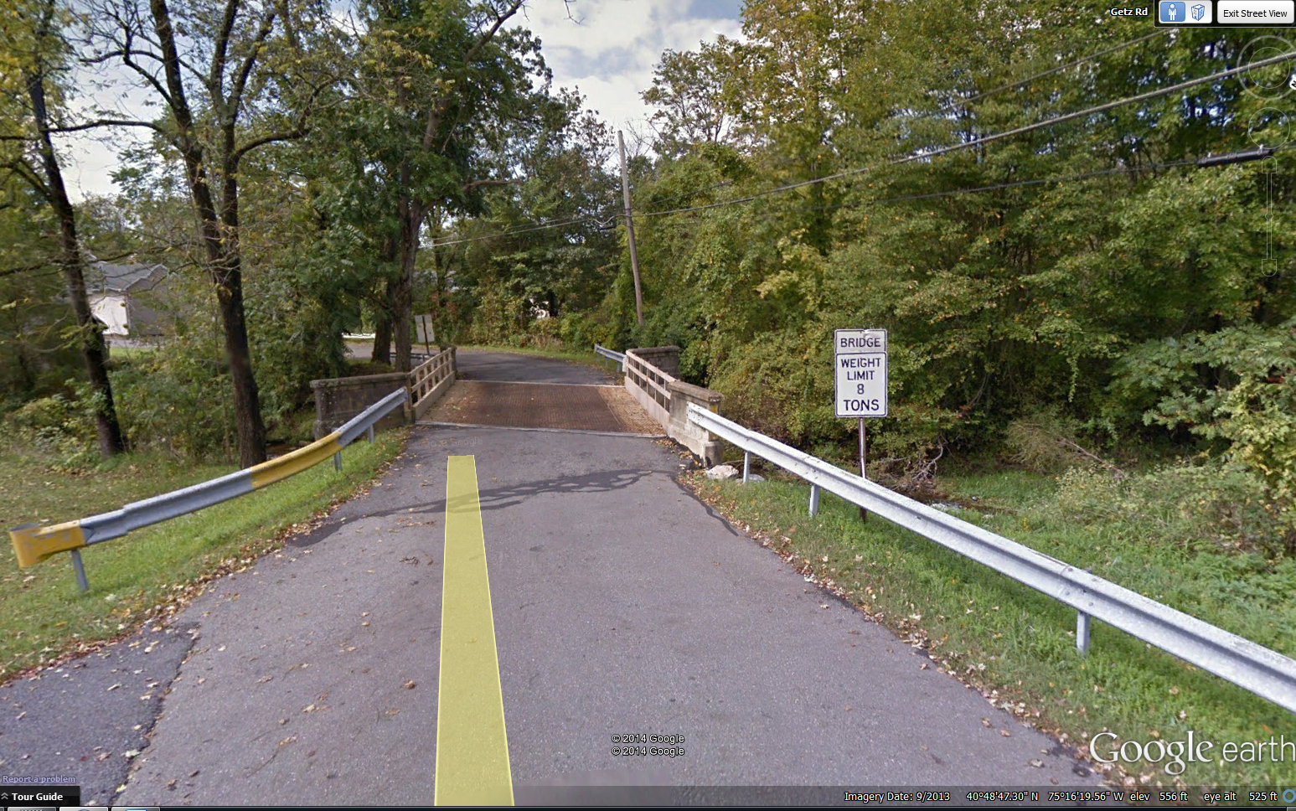

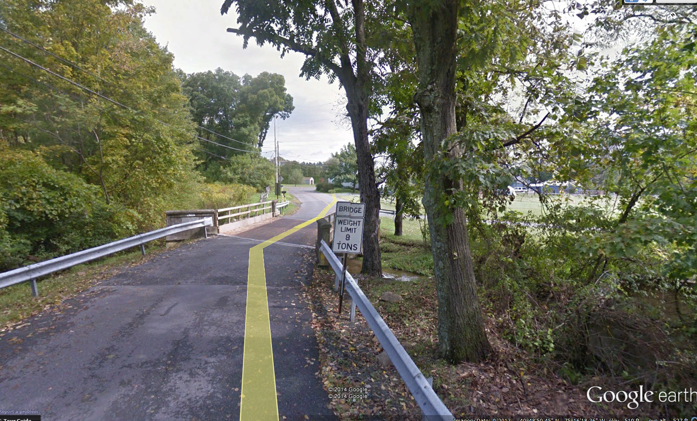

**210: 48-7208-0692-9210: 28846**: Single span. Bituminous pavement. Medium height over wide shallow creek. Design load unknown.

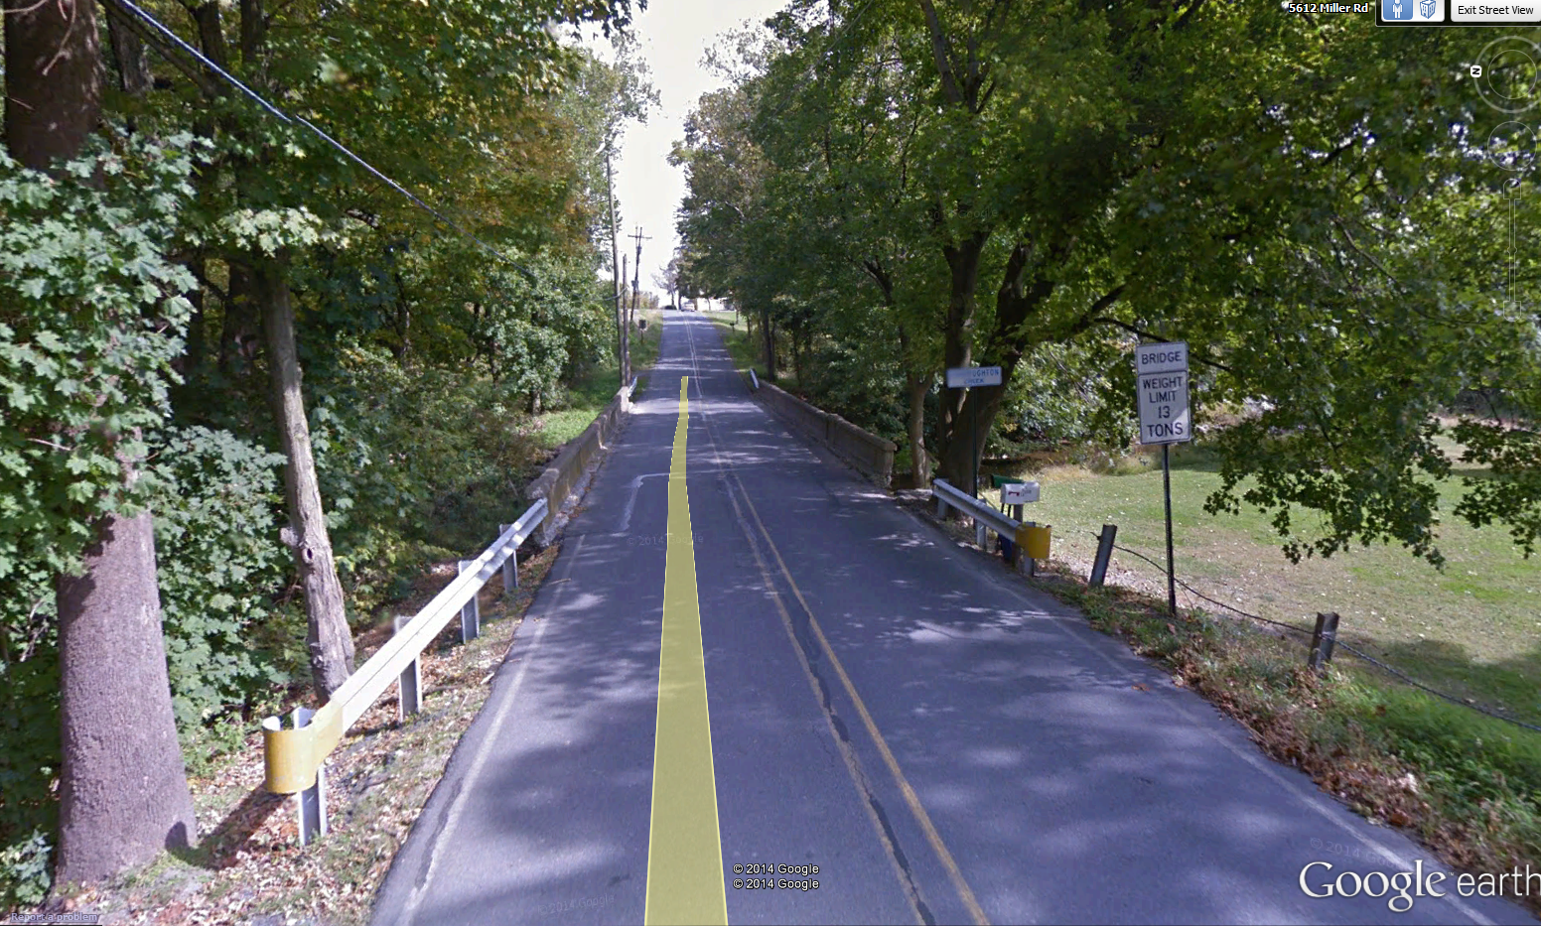

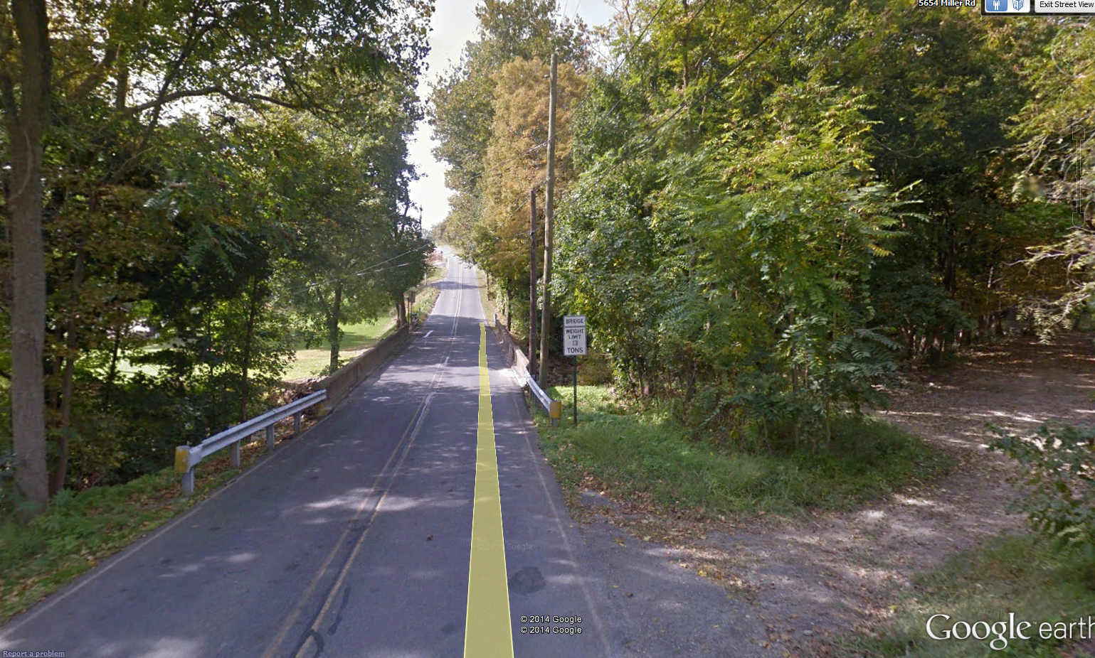

**213: 48-7213-0629-9213: 28865**: Single span. Bituminous pavement. Extremely low over wide shallow creek. Looks monolithic with abutments. Design load unknown.

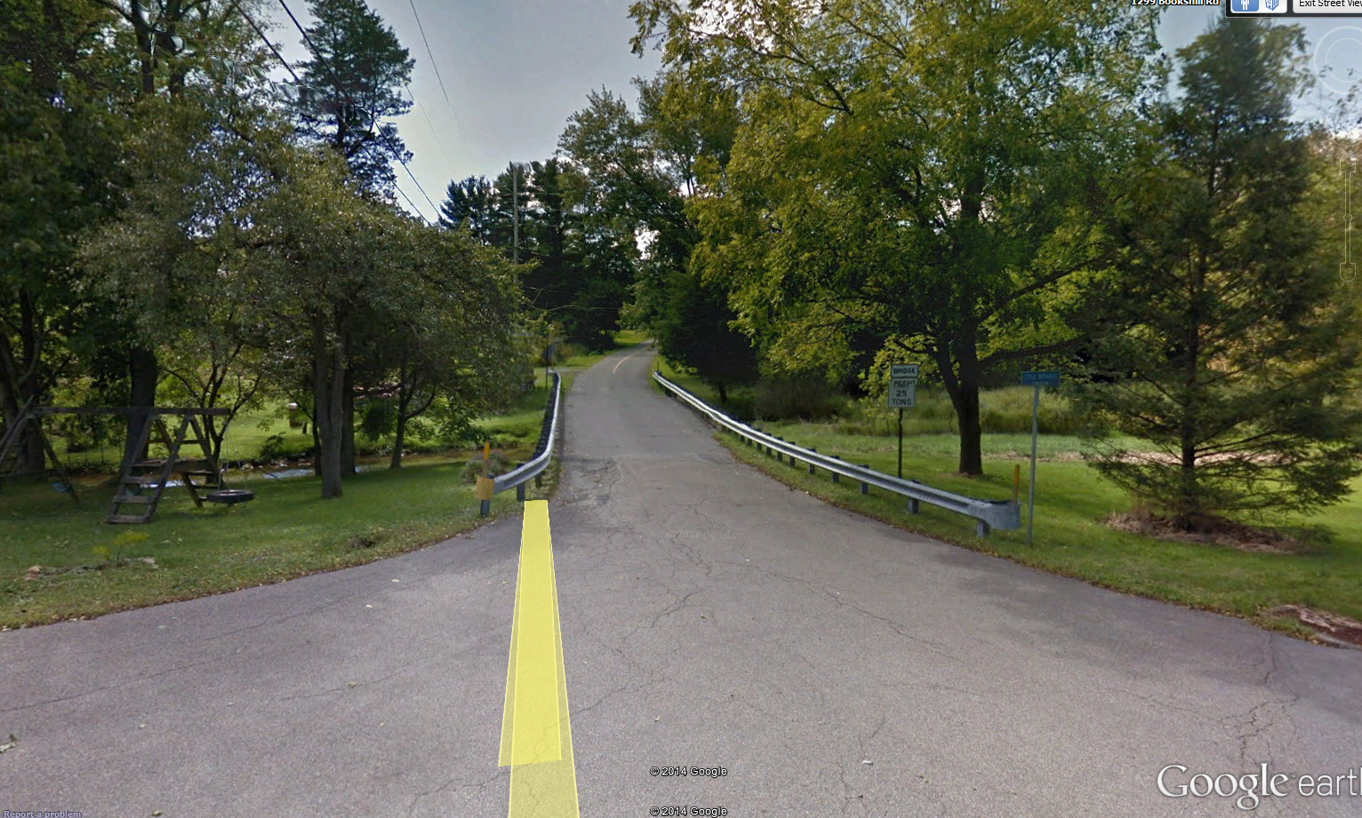

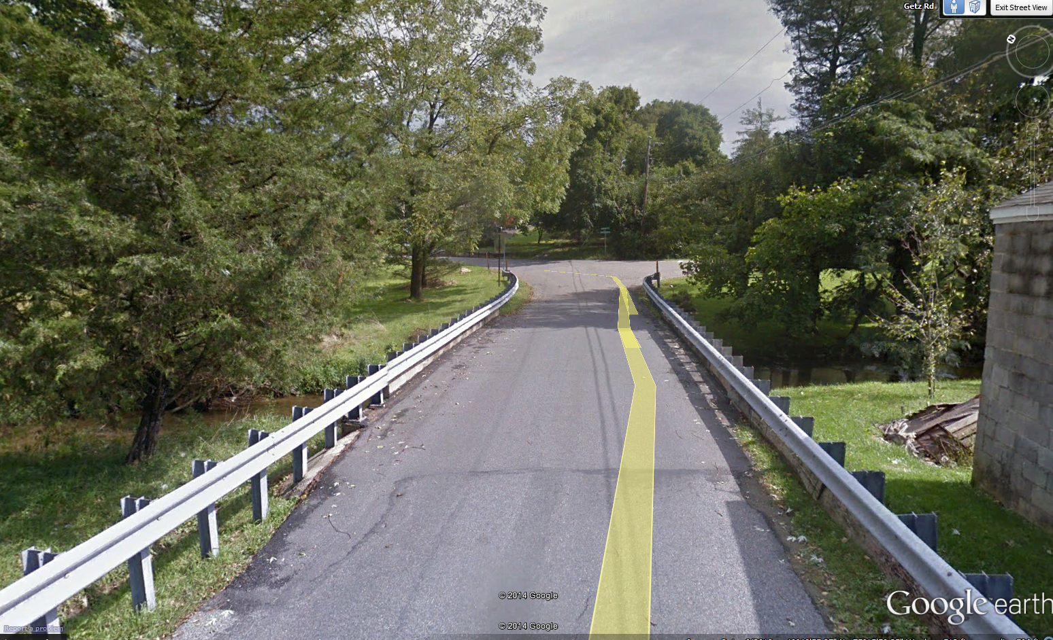

**215: 48-7208-0690-9215: 28845**: Single span. One lane. Concrete deck. High over shallow creek. Narrow/blind approaches. Narrow structure (15.5’). Design load unknown.

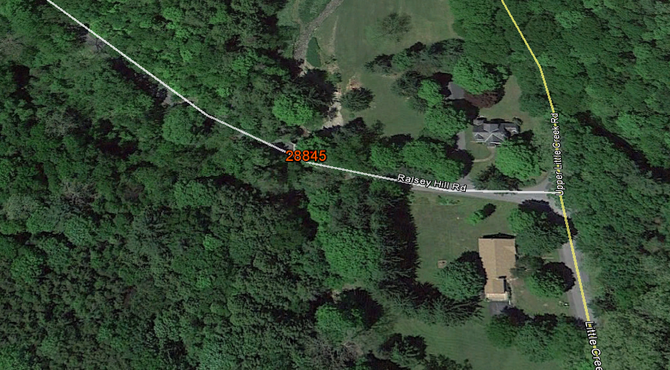

**224: 48-7215-0511-9224: 28891**: Single span. Bituminous pavement. One lane. Medium height over creek. No obvious staging area. 16’ roadway.

